TU Rec App User Documentation

Install:

Upon release, our app will be available on android devices through the google play store. Enter TURecApp into the search bar in the store, and the app will be available for download. The app is not yet on the store, so to launch today you must open the source code in android studio. Once you have an emulator in your android studio (for example google pixel 2), you can install the app remotely.

Navigation is simple for this app, there is a blue bar at the top with an arrow that can be used to visit the previously visited screen, usually the main screen. On the same blue bar, users can edit their app settings including background color as well as editing/viewing information the app has saved about them. If users have questions, they can click the mail logo at any time to speak with rec center support.

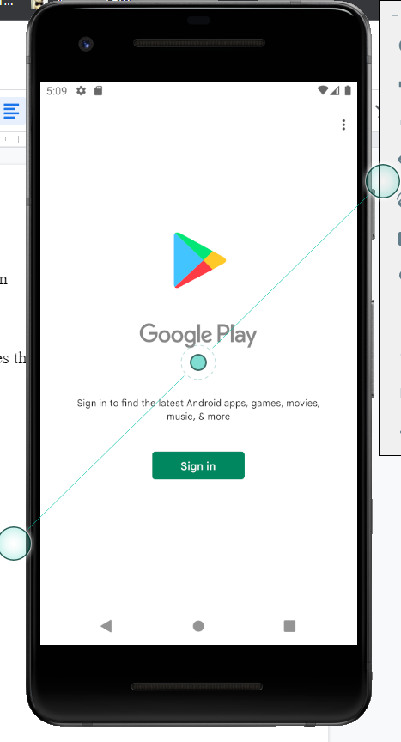

Login:

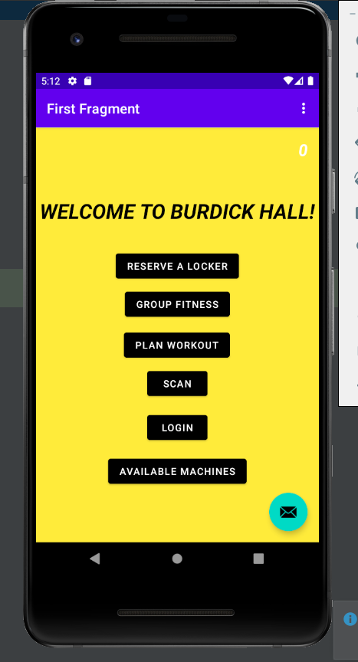

When users load the app, they will be taken to the main screen. Here users can select 6 buttons to navigate through the app for their desired use, and view the capacity counter in the top right. The first step to access other features is users must login by clicking the login button. From this screen, users enter their towson email and password, click the login button, and these credentials are validated in the system. Users only need to login one time and once they login, they can access all features of the app.

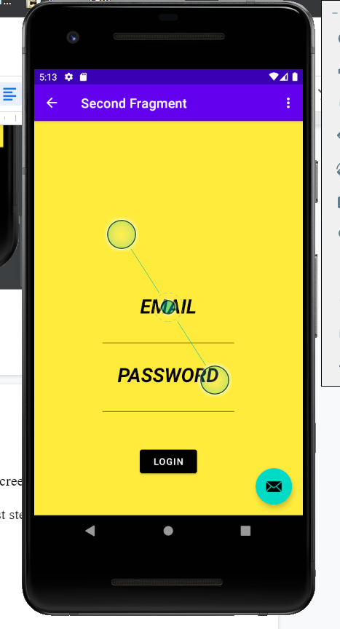

Reserve a locker:

If a user would like to reserve a locker inside the app, they must use the reserve a locker button on the main screen. Users are now presented the locker reservation view, where they use the button at the bottom to reserve an available locker. The system will assign the user a locker and present them with the locker number as well as the time they have remaining for their reservation.

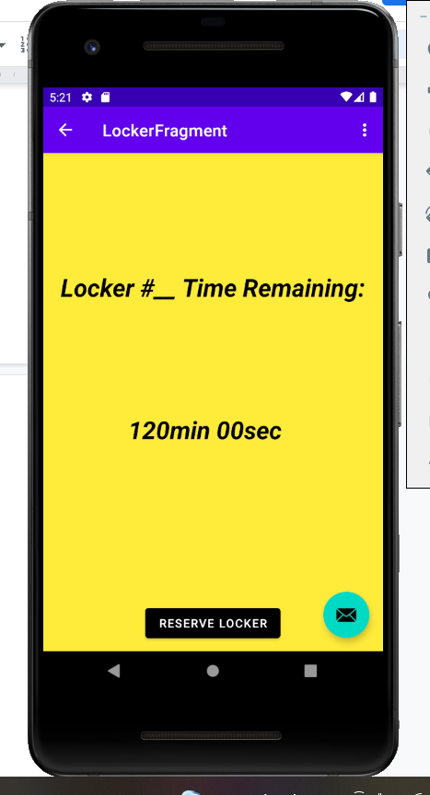

Group Fitness/Intramurals:

If users want to participate in group fitness classes or intramurals, they should use the group fitness button on the app’s main screen. Here, users can enter their name, contact email and what class they would like to join. An email will be provided to them notifying them if they have been successfully added to this class, or if they haven’t. If the user wants to view information about intramural sports they should click the “Register for Intramural Sports” button. This button will take users to the TU campus rec intramural sports website.

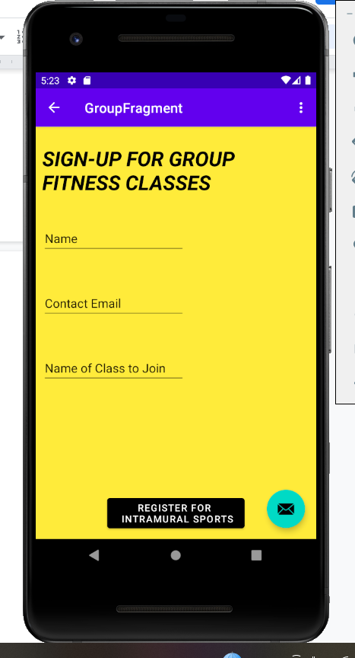

Plan Workouts:

If users would like to view workouts and make a plan, they should select the Plan Workout button from the main screen. Here, users can enter their height, weight and age which will affect the type of workouts the system will recommend to them. The database will save these entries for the user so they won’t have to enter these everytime. On this same screen, users can see different types of workouts and how many calories they can burn from them. If users want to do a specific type of workout, they can click the button for that workout and the system will display a workout that it recommends to the user on the bottom of the screen.

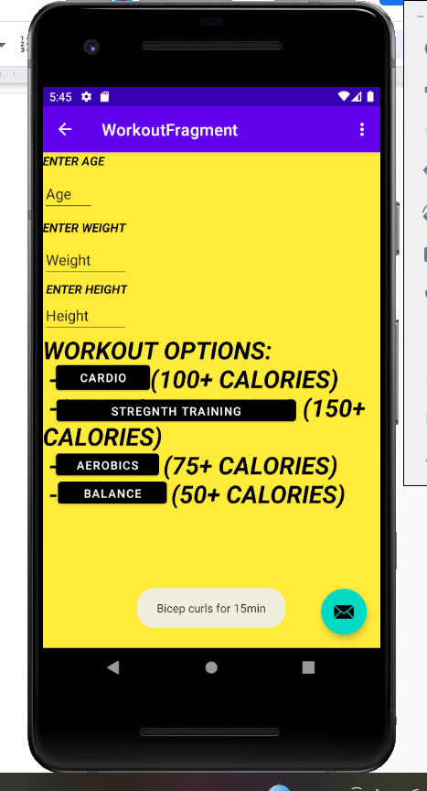

Scan-in:

When users enter the gym, they will need to scan a qr code that is displayed at the gym. On their app, they should hit the scan button on the main screen. From there, users will have to allow camera permissions if they have not already. Users will click the open camera button, then capture a photo of the qr code at the gym. Once this photo is uploaded to the app, the system will communicate user information stored in the app with the rec center, attempting to validate their entry into the gym. If all goes through, the capacity counter on the main screen will update by 1, and the user will be permitted through the system to enter the gym(the capacity counter decreases by one when someone exits the facility).

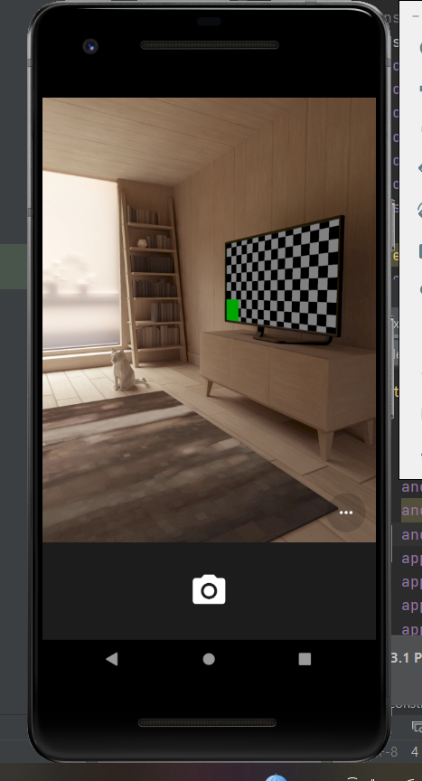

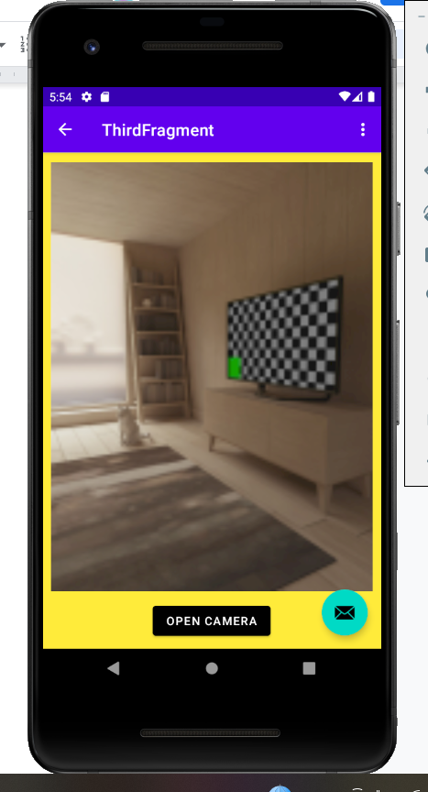

View Available Machines:

If users would like to know how many machines are available, all they need to do is simply use the Available Machines button on the main screen, and the system will display the count of available machines at the gym at that given time. This number is acquired from sensors installed at machines at the gym that communicate with the app. Users can use this feature to plan when they want to visit.

